## Nanoleaf Canvas Smarter Kit (9 Panels) Easily Create Your Own Lighting ...

**Pairing Your Panels for iOS**

To ensure a smooth pairing process, please make sure you have the following things ready:

**Your Device**

Requires iOS 12+

**Pairing Code**

Can be found on your Welcome Card, Controller or PSU.

**2.4 GHz Wi-Fi Network**

5 GHz networks are not compatible with Nanoleaf products.

**Connected Controller**

The controller is ready when the Status LED is solid white.

1. **Download and Open the Nanoleaf App**

You can find the official **Nanoleaf App** in the App Store. Make sure you have the latest version.

1. **Pair Your Shapes**
   1. On the Dashboard, tap the pencil icon in the top right corner.
   2. Tap “Add Device +”
   3. Under Decor, Select Shapes as your product.
   4. The app will automatically open up the pairing window.
   5. Follow the instructions on the screen to either:

**Option A:** Scan the QR code

**Option B:** Enter in the 8-digit pairing code found on your Elements

Power Supply Unit, Controller, or Quick Start Guide/Welcome Card

**Option C:** Use NFC Tap, by holding the top of your mobile device over the buttons of your Controller

* 1. Your Nanoleaf Shapes should now be connected and ready to go.

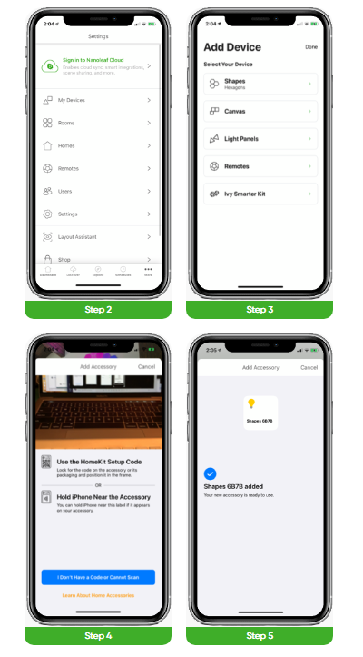

**How can one setup be controlled by multiple iOS users?**

This is accomplished with the Apple Home App and the Nanoleaf App.

**Primary User**

1. Open the Nanoleaf App.
2. Select the **More** tab.
3. Select **Users**.
4. Invite the secondary user with their iCloud Account.

**Secondary User**

1. A notification will appear for you to accept.
2. In the Home App, select the home icon in the top left.
3. Select **Home Settings**, a list of homes will appear.
4. Accept the home that has been shared with you. This will give you control of the Lines as well as any other HomeKit devices in the same home.

**Pairing Your Panels for Android**

To ensure a smooth pairing process, please make sure you have the following things ready:

**Your Device**

Requires Android 9+

**Pairing Code**

Can be found on your Welcome Card, Controller or PSU.

**2.4 GHz Wi-Fi Network**

5 GHz networks are not compatible with Nanoleaf products.

**Connected Controller**

The controller is ready when the Status LED is solid white.

1. **Download and Open the Nanoleaf App**

You can find the official **Nanoleaf App** in the Google Play Store. Make sure you have the latest version.

1. **Pair Your Shapes**
2. On the Dashboard, tap the pencil icon in the top right corner.
3. Tap “Add Device +”
4. Under Decor, Select Shapes as your product.
5. The app will automatically open up the pairing window.
6. Follow the instructions on the screen to either:

**Option A:** Scan the QR code

**Option B:** Ensure that NFC is enabled. Hold the top of your device

over the buttons on your controller to pair.

**Option C:** Select the product you want to pair. Once identified, **tap to**

**Pair**. Enter your 8-digit pairing code (found on the Quick Start

Guide, PSU, or Controller).

1. Your Nanoleaf Shapes should now be connected and ready to go.

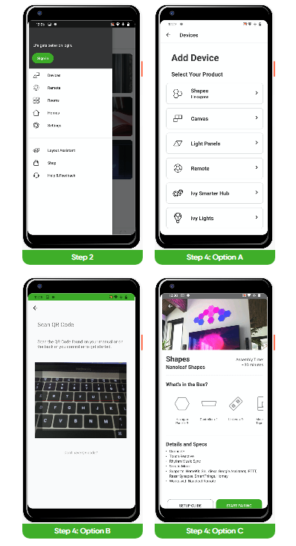

## **Controlling Your Panels**

### Controller

The Controller is the brain of the Nanoleaf Shapes. The touch control buttons on the Controller provide convenient shortcuts to common commands. The Controller can be attached to any available linker slot in your layout.

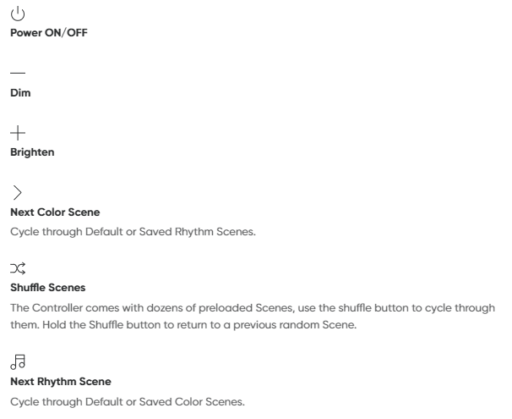

**Advanced Button Controls**

You can also use the Controller’s touch buttons for advanced commands—most commands can be executed by holding buttons, or tapping two buttons at once.

Here is a full list of shortcuts:

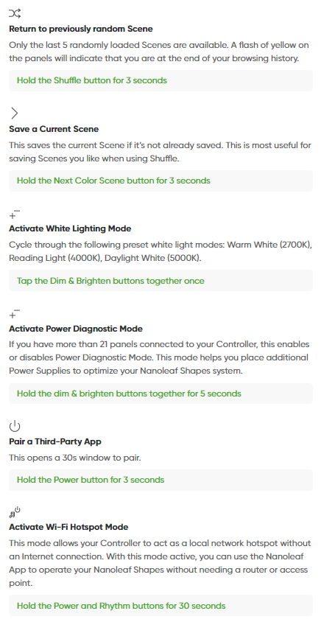

**Touch Actions**

Touch Actions transform each light panel into a smart button, allowing for the most seamless control of your entire smart home. With as little as a single press on a panel, activate HomeKit Scenes to control any or all of your HomeKit products at once.

**Touch Gestures**

Touch Gestures can be used to change brightness and Scenes or turn your Shapes on and off.

**Nanoleaf App**

Turn your lighting on and off, control brightness, group lights by home and by room, create and use Scenes, and much more.

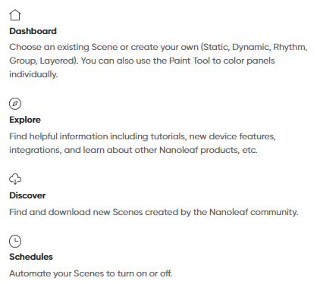

### Voice Control

You can easily control your Shapes by voice in a few different ways. In the Nanoleaf App, make sure to name your panels with something simple.

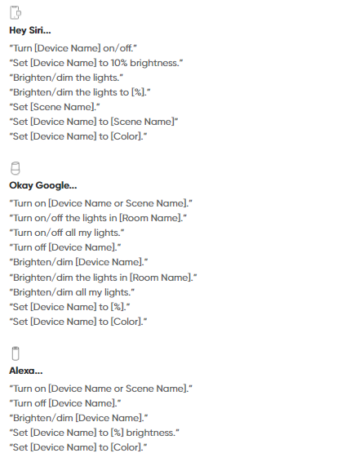

**Problems & Solutions**

**Reset**

This will reset the Wi-Fi and all saved pairing configurations. Your saved scenes will remain.

1. Press and hold the Power and brighten buttons together on the Controller for 15 seconds.
2. Let go once the Status LED starts flashing.
3. Wait for the Power button LED to remain on and steady.
4. On the Nanoleaf App, delete the previous device and re-pair it again.

**Common Solutions**

**“My Shapes are paired but unreachable.”**

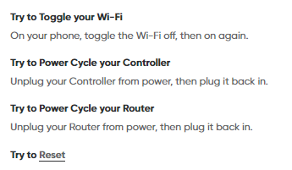

**“I am not able to pair my Shapes.”**

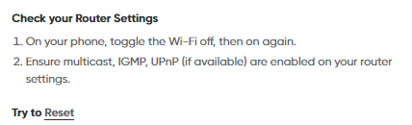

**“I don’t see my Shapes in the App for setup.”**

