**Closed-Loop Zippers (Tents)**

STEP 1) With a seam ripper, remove stitching around lower end of zipper.

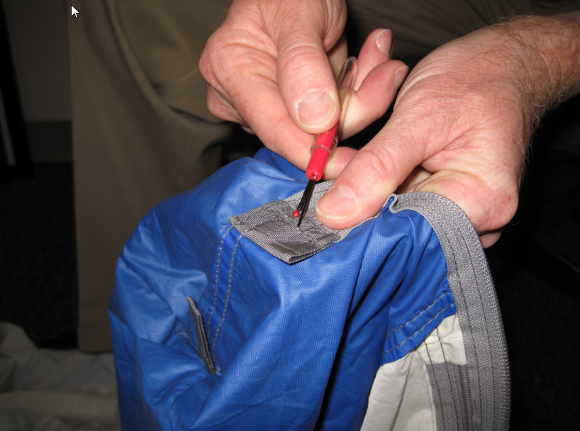

STEP 2) If present, pry off metal stop at bottom of zipper; be careful not to tear the fabric at the base of the zipper teeth. Remove old zipper slider.

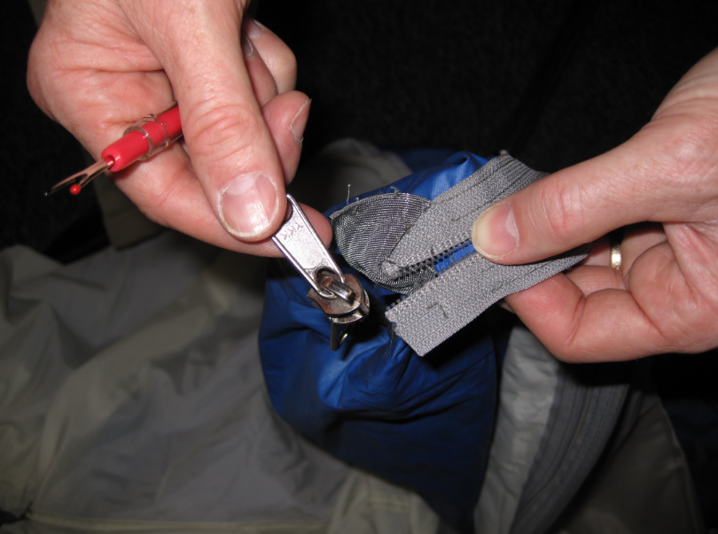

STEP 3) Take new zipper slider and guide zipper teeth into the top grooves of the slider, pushing them through to the bottom. Use a pin if needed to work the zipper hem through.

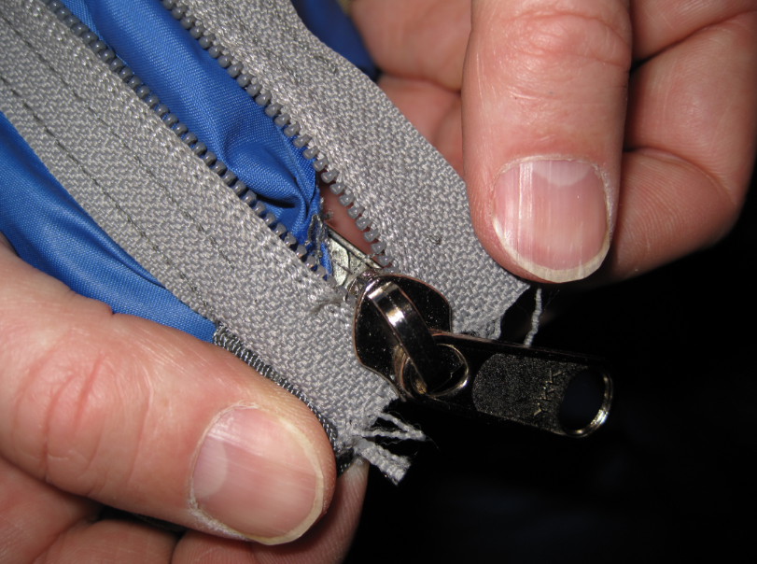

STEP 4) Pull zipper gently to ensure slider sits evenly on zipper tracks. Sliders should only be installed “nose first.”

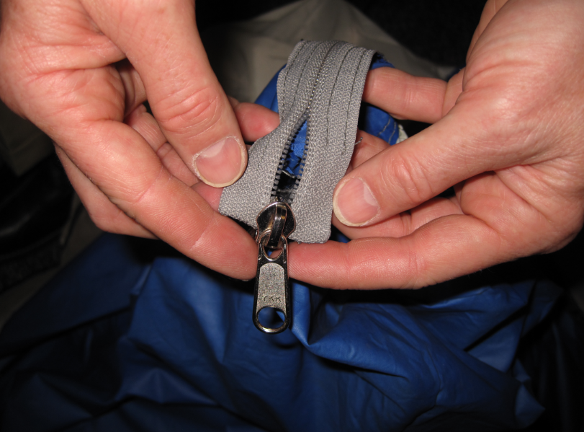

STEP 5) Pull slider up until locked track teeth appear at bottom.

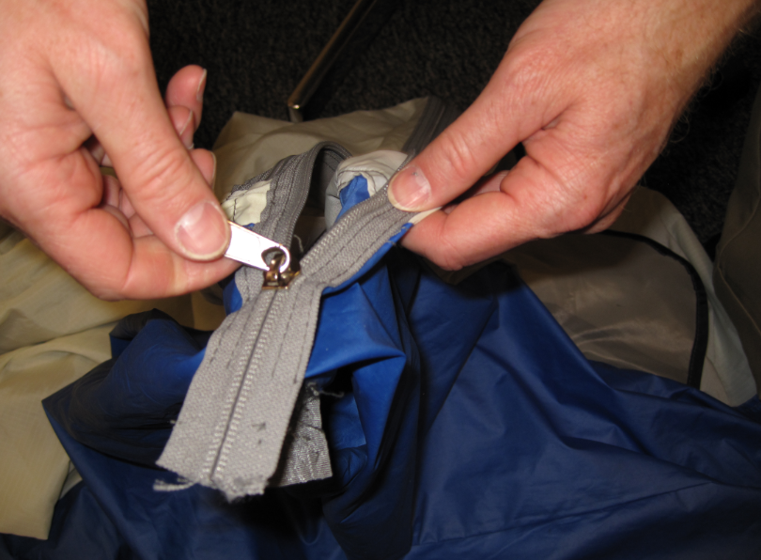

STEP 6) Sew a new stop at bottom of zipper tracks with needle and thread.

